CHAPTER 19
THE FIRST LAW OF THERMODYNAMICS
Discussion Questions

Q19.1 (a) positive (volume of the gas increases) (b) positive (volume of the gas increases) (c) negative (volume of the gas decreases) (d) negative (volume of the gas decreases).

Q19.2 Heat is transferred from one object to another because of a temperature difference. We can’t say that a body contains a certain amount of energy because heat is not a state function; the amount of heat transferred into or out of an object in a process is path dependent.

Q19.3 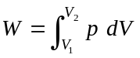. 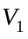 and 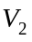 are the same. When the balloon is inflated the total outward force due to the presence of the air inside the balloon must equal the total inward force due to the pressure of the surrounding air and the force due to the stretching of the balloon material. When the air pressure outside the balloon is less, less pressure inside the balloon is needed to inflate it to a given size. Hence, less work needs to be done to inflate the balloon at the summit of Mt. McKinley.

Q19.4 No, the work and heat transfer are both path dependent. For different paths between the initial and final states the work and heat transfer can be different.

Q19.5 Heat energy enters her body from the chemical processes that metabolize the food. Energy leaves her due to the work of raising herself against gravity and as heat that evaporates her perspiration. If her body temperature rises, this is due to some of the food energy that stays in her body. The first law says energy input = work output + heat output + increase in internal energy. During the descent gravity does positive work on her but she still performs work by the contraction of her muscles. The energy input from the food is again what warms her. During the descent she performs less work and less food energy needs to be inputed.

Q19.6 For a volume decrease 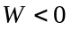. 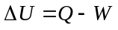 so 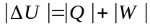; the internal energy change is greater than the heat added.

Q19.7 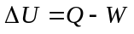. If we treat the air inside the balloon as an ideal gas U for the gas depends only on its temperature. During the expansion the temperature increases and 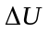 is positive. Therefore, the heat Q added to the balloon is greater than the work done by the air inside it. When the balloon has returned to its original temperature, 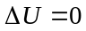. Therefore 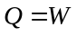; the net heat flow to the air equals the net work done.

Q19.8 Since the container is open to the air in the room, the pressure inside the container is constant, always equal to the air pressure in the room. Therefore, the process is isobaric. Heat flows out as the air cools (so the process is not adiabatic), the temperature decreases (so is not isothermal) and the volume of the air that was originally in the container decreases (so not isochoric).
Q19.9 In the expansion the repulsive force between the electrons would do positive work as the electrons move apart. 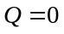 and 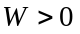 so 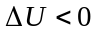 and the temperature would fall.

Q19.10 . For an adiabatic process 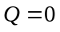 and 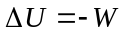. For an adiabatic process, 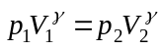, where 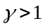. 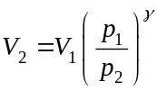. If the pressure decreases, 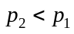 and 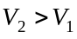. For any process, when the volume increases the work done is positive. Therefore, in this process 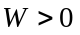 and is negative. The internal energy decreases.

Q19.11 With your mouth wide open there is little expansion work. The air from your lungs is at body temperature so is warmer than the air outside your body (unless you do this experiment in Texas in August!) so feels warm. When you constrict the opening of your mouth the air expands through this opening and is cooled, in an adiabatic expansion.

Q19.12 so 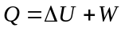. When the gas expands its volume increases and . 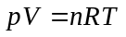 says that T increases, since V increases and p is constant. 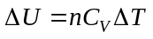 for an ideal gas. Since T increases, is positive. and both and W are positive, so Q is positive.

Q19.13 . Since the container is well-insulated, no heat has been transferred and . Work has been done on the liquid, so 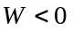. The force exerted during the stirring moves the liquid in the direction of the force so positive work is done by the stirring force. Irregular stirring increases the force applied to the liquid and thereby increases the work done on the liquid. and , so 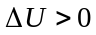. The internal energy increases and this corresponds to an increase in temperature of the liquid.

Q19.14 The adiabatic compression of the air in the pump heats the air. 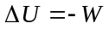. In the compression so 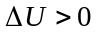. In the adiabatic expansion of the air in the pump cylinder when you raise the handle, the air is cooled. In the expansion so .

Q19.15 In the adiabatic expansion of the air it is cooled and can in fact be cooled below 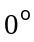C.

Q19 .16 The air in the bubble first expands due to the heat flow into it from the surrounding earth. This initial expansion causes the warmer air in the bubble to be less dense than the surrounding air. The mass of lighter air rises and as it does it cools due to its adiabatic expansion at the lower pressure that exists at the higher altitude. The thermal stops rising when it has cooled to the same temperature as the surrounding air. The expansion of the air bubble is approximately adiabatic because the air rises rapidly. Also, air is a poor conductor of heat so little heat flows out of the air bubble as it expands.

Q19.17 The air does positive work to raise itself against gravity. This is approximately an adiabatic process so and for , and the air cools.

Q19.18 As the air moves downward on the smooth western slope positive work is done on the air by gravity so . The process is approximately adiabatic so and for , and the air warms.

Q19.19 By definition 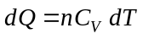 for constant volume and 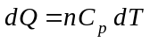 for constant pressure. In any process, 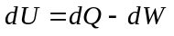. For constant volume 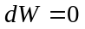 and 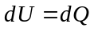. For constant pressure, 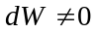 and 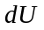 is 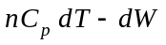.

Q19.20 The energy comes from the work done on the gas by the external force that compresses it.

Q19.21 The energy comes from the internal energy of the gas, and that is why the gas cools.

Q19.22 The 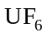 molecule has many more internal degrees of freedom (rotation, vibration) than 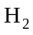 does. Therefore, more heat is required for a given temperature change for than for , because for a larger fraction of the heat added goes into the internal motions of the molecule and less into the translation motion that determines the temperature. Said another way, 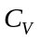 for the polyatomic molecule is larger than for the diatomic molecule (see Table 19.1), so a given amount of heat flowing into the gas gives a smaller temperature rise for .

Q19.23 (a) The work done equals the area under the path in the 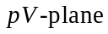. This is greatest for path 1 so the work done by the system is greatest for path 1. It is least for path 3 so the work done by the system is least for path 3. (b) . is positive and is the same for all three paths so  is largest when is largest and this is for path 3. 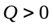 and heat is absorbed by the system.

Q19.24 (a) and (b). The magnitude of the work done for each loop equals the area enclosed by the loop and the magnitude of the work done along a path equals the area under the path. For loop I the positive work done while the volume is increasing is larger in magnitude than the negative work done while the volume is decreasing, and the net work done by the system is positive. For loop II the negative work done while the volume is decreasing is larger in magnitude than the positive work done while the volume is increasing and the net work done by the system is negative. The area enclosed by loop I is larger than the area enclosed by loop II so the net work done by the cycle is positive. (c) and (d) For a closed loop, and . For loop I is positive, is positive and heat flows into the system. For loop II is negative, is negative and heat flows out of the system. For the complete cycle the net work done is positive so the net heat flow is positive.

